**Ex:** 5

**Date:** 13/10/2020

**Aim:**

To create a python program to check if all alphabet are presented at least once in

in the given sentence and display the unavailable alphabets.

**Program:**

def pangram(p):

s="abcdefghijklmnopqrstuvwxyz"

ca=[pan for pan in s if pan is p]

cb=[npan for npan in s if npan not in p]

if(len(ca)==26):

r="".join([str(i) for i in ca])

return r

else:

r="".join([str(i) for i in cb])

return r

sa=str(input())

sa=sa.lower()

pa=pangram(sa)

print(pa)

**Output:**

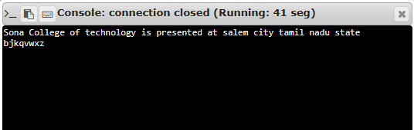

**Result:**

Thus creating a python program to check if all the alphabets present in the given sentence at least once or not is done.

**Link:**

<http://103.53.53.18/mod/vpl/forms/submissionview.php?id=235&userid=1652>